

**Green University of Bangladesh**

**Department of Computer Science and Engineering (CSE)**

**Faculty of Sciences and Engineering**

**Semester: (Summer, Year: 2021), B.Sc. in CSE (Day)**

**Course Title: Structured Programming Lab**

**Course Code: CSE 104 Section: 211DE**

**Lab Project Name: Hospital Management System**

**Student Details**

|  |  |  |
| --- | --- | --- |
| **Name** | | **ID** |
| **1.** | **Md. Israil Fakir** | **221902125** |

**Submission Date: _ _ _ _ _ _ _ _ _ _ _ _ _ _ _ _ _ _ _ _ _ _ _ _**

**Course Teacher’s Name: Md. Parvez Hossain**

**[For Teachers use only: Don’t Write Anything inside this box]**

|  |
| --- |
| **Lab Project Status**  **Marks: ………………………………… Signature: .....................**  **Comments: .............................................. Date: ..............................** |

Table of Contents

**Chapter 1 :Introduction** 1

1.1 Introduction 3

1.2 Design Goals/Objective 5

**Chapter 2** 6

**Implementation of the Project** **7**

2.2 Implementations 8

2.3 Screenshots 9

**Chapter 3 Conclusion** **10**

3.1 Learning Outcome 12

3.2 Future Scope 13

**References** **14**

# Chapter 1 Introduction

## Introduction

Originally, C language is developed from two previous languages, BCPL and B. BCPL which were developed in 1967 by Martin Richards as a language for wring operating systems and compilers. C was evolved from B by Dennis Ritchie at Bell Laboratories and it was implemented in 1972. It initially became widely known as the development language of the UNIX operating system. Lots of today’s leading operating systems are written in C and C++. C language is mostly hardware independent as it is possible to write C programs that are portable to most computers.

Why we use c language C has been used successfully for each kind of programming problem thinkable from operating systems to spreadsheets to expert systems - and efficient compilers are accessible for machines ranging in power from the Apple Macintosh to the Cray supercomputers. The largest measure of C's success appears to be based on strictly sensible considerations:

1. The standard library concept;
2. the ease with that applications can be optimized by hand-coding isolated procedures;
3. a powerful and varied repertoire of operators;
4. the portability of the compiler;

## Design Goals/Objective

The goal of the project is to design an Airline Reservation Systems:

A small airline has just purchased a computer for its new automated reservation system. The owner has asked to program the new system in C. It is required to write a program to assign seats on each flight of the airlines only place (capacity: 15 seats). The program should never assign a seat which is already assigned. If there’s no seat available, then print the message " the flight is full ".

After the flight is full and someone want to cancel the booking, it is displaying enter you’re the passport number you want to cancel it so after the passenger cancel it, the system directly free that place id someone want to book that seat.

Moreover, the system should bring a boarding pass indicating the persons' name, passport number and seat number as each seat is assigned, set the corresponding elements of array to 1 to indicate that seat is no longer available.

# Chapter 2

# Implementation of the Project

## Flow Charts

When the program is started, the user will direct to the main menu. The user will be required to select one of the four options.

## 

**Figure1: Flow Chart of Main Menu**

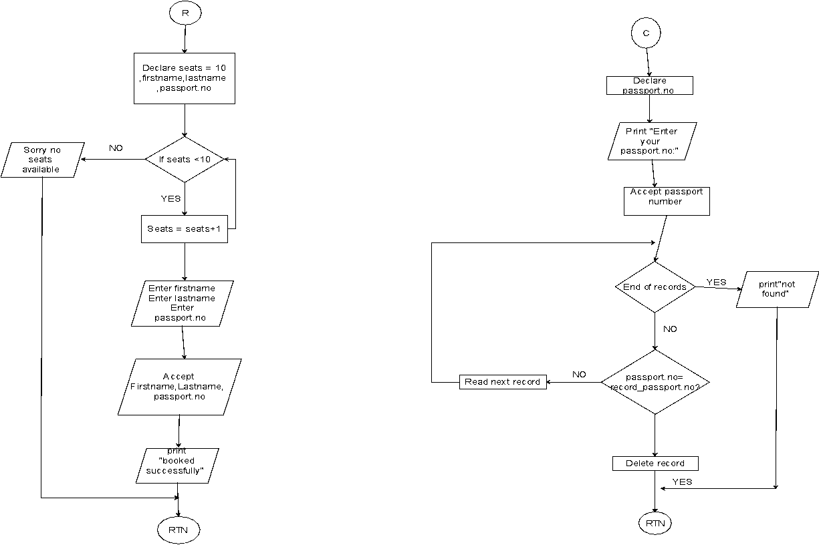

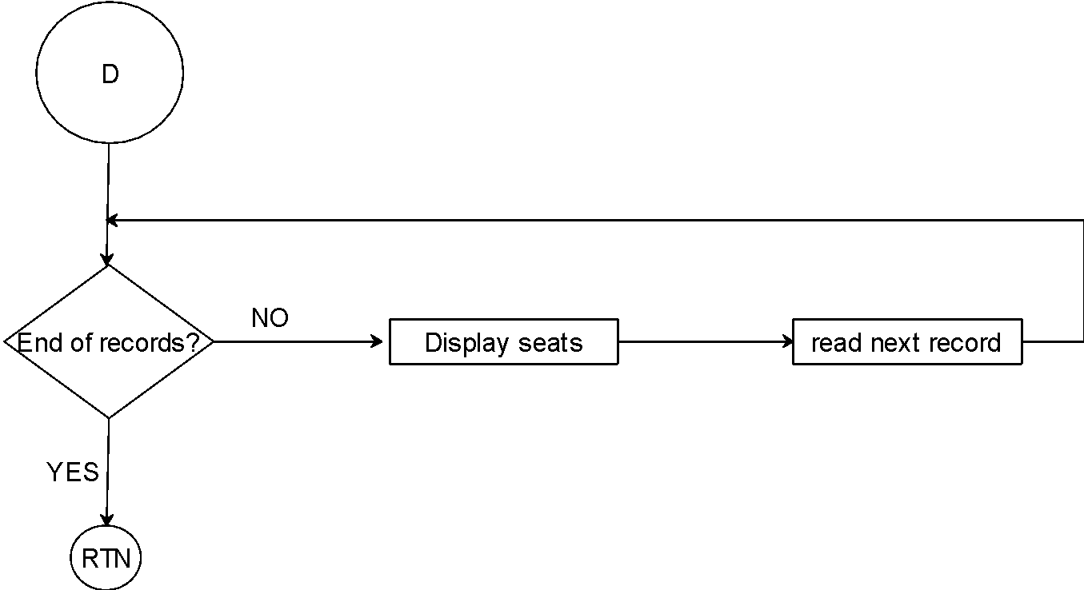

**Figure 2: Flow Chart of different Activities involved in different functions of the project**

1. **Implementation**

C source code

1. #include<stdio.h>
2. #include<stdlib.h>
3. #include<conio.h>
4. #include<string.h>
5. #include<Windows.h>
6. struct mufti_airline
7. {
8. char passport[6];
9. char name[15];
10. int seat_num;
11. char email[15];
12. struct mufti_airline *following;
13. }
14. *begin, *stream;
15. struct mufti_airline *dummy;
16. void main()
17. {
18. void reserve(int x), cancel(), display(), savefile(); //function prototypes
19. int choice;
20. begin = stream = NULL; //initialize the struct pointers to NULL
21. int num = 1;
22. do
23. {
25. printf("\n\n\t\t ********************************************************************");
26. printf("\n\t\t welcome to mufti's airline system ");
27. printf("\n\t\t *******************************************************************");
28. printf("\n\n\n\t\t Please enter your choice from below (1-4):");
29. printf("\n\n\t\t 1. Reservation");
30. printf("\n\n\t\t 2. Cancel");
31. printf("\n\n\t\t 3. DISPLAY RECORDS");
32. printf("\n\n\t\t 4. EXIT");
33. printf("\n\n\t\t feel free to ask us");
34. printf("\n\n\t\t Enter your choose ");
35. scanf("%d", &choice); fflush(stdin);
36. system("cls");
37. switch (choice)
38. {
39. case 1:
40. reserve(num);
41. num++;
42. break;
43. case 2:
44. cancel();
45. break;
46. case 3:
47. display();
48. break;
49. case 4:
50. {
51. savefile();
52. break;
53. }
54. default:
55. printf("\n\n\t SORRY INVALID CHOICE!");
56. printf("\n\n\t PLEASE CHOOSE FROM 1-4");
57. printf("\n\n\t Do not forget to chose from 1-4");
58. }
59. getch();
60. } while (choice != 4);
61. }
62. // ************************GOOD LUCK MUFTI*****************************
63. void details()
64. {
65. printf("\n\t Enter your passport number:");
66. gets(stream->passport); fflush(stdin); //reads a line from stdin and stores it into the string pointed
67. printf("\n\t Enter your name:");
68. gets(stream->name); fflush(stdin);
69. printf("\n\t Enter your email address:");
70. gets(stream->email); fflush(stdin);
71. }
72. // ************************************GOOD LUCK MUFTI************************************
73. void details();
74. void reserve(int x)
75. {
76. stream = begin;
77. if (begin == NULL)
78. {
79. // first user
80. begin = stream = (struct mufti_airline*)malloc(sizeof(struct mufti_airline));
81. details();
82. stream->following = NULL;
83. printf("\n\t Seat booking successful!");
84. printf("\n\t your seat number is: Seat A-%d", x);
85. stream->seat_num = x;
86. return;
87. }
88. else if (x > 15) // FULL SEATS
89. {
90. printf("\n\t\t Seat Full.");
91. return;
92. }
93. else
94. {
95. // next user
96. while (stream->following)
97. stream = stream->following;
98. stream->following = (struct mufti_airline *)malloc(sizeof(struct mufti_airline));
99. stream = stream->following;
100. details();
101. stream->following = NULL;
102. printf("\n\t Seat booking succesful!");
103. printf("\n\t your seat number is: Seat A-%d", x);
104. stream->seat_num = x;
105. return;
106. }
107. }
108. // ************************GOOD LUCK MUFTI********************************
109. void savefile()
110. {
111. FILE *fpointer = fopen("mufti records", "w");
112. if (!fpointer)
113. {
114. printf("\n Error in opening file!");
115. return;
116. Sleep(800);
117. }
118. stream = begin;
119. while (stream)
120. {
121. fprintf(fpointer, "%-6s", stream->passport);
122. fprintf(fpointer, "%-15s", stream->name);
123. fprintf(fpointer, "%-15s", stream->email);
124. stream = stream->following;
125. }
126. printf("\n\n\t Details have been saved to a file (mufti records)");
127. fclose(fpointer);
128. }
129. //********************************GOOD LUCK MUFTI***************************************
130. void display()
131. {
132. stream = begin;
133. while (stream)
134. {
135. printf("\n\n Passport Number : %-6s", stream->passport);
136. printf("\n name : %-15s", stream->name);
137. printf("\n email address: %-15s", stream->email);
138. printf("\n Seat number: A-%d", stream->seat_num);
139. printf("\n\n++*=====================================================*++");
140. stream = stream->following;
141. }
142. }
143. //*****************************GOOD LUCK MUFTI*************************************
144. void cancel()
145. {
146. stream = begin;
147. system("cls");
148. char passport[6];
149. printf("\n\n Enter passort number to delete record?:");
150. gets(passport); fflush(stdin);
151. if (strcmp(begin->passport, passport) == 0)
152. {
153. dummy = begin;
154. begin = begin->following;
155. free(dummy);
156. printf(" booking has been deleted");
157. Sleep(800);
158. return;
159. }
160. while (stream->following)
161. {
162. if (strcmp(stream->following->passport, passport) == 0)
163. {
164. dummy = stream->following;
165. stream->following = stream->following->following;
166. free(dummy);
167. printf("has been deleted ");
168. getch();
169. Sleep(800);
170. return;
171. }
172. stream = stream->following;
173. }
174. printf("passport number is wrong please check your passport");
175. }

**Screenshots**

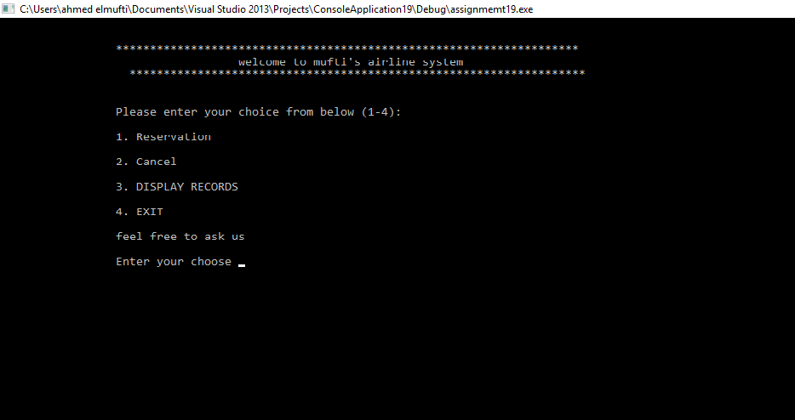

*Figure 3: Main Menu interface*

When the program is executed, the user will be directed to the main menu interface. The program is introduced with a few lines of texts. Then four selections are made for the user as the user can choose to reserve, cancel, display or exit the program.

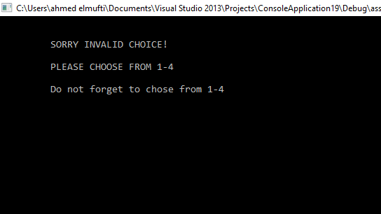

*Figure 4: Invalid value entered (main menu)*

. If the user accidentally enters an invalid input, an interface will be shown to notify the user to choose again and it notify the user again to enter from 1-4.

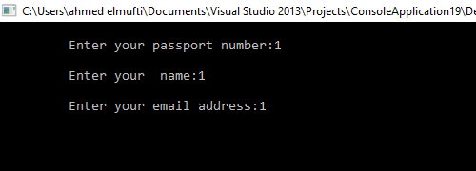

*Figure 5: Reservation function*

The program is asking the user to enter passport number, name, and the email address to reserve a seat for the user and the seat cannot be book for anyone else.

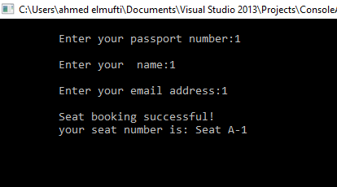

*Figure 6: the seat has successfully booked*

As shown in the interface the seat reservation has been booked successfully, after the user has entered the details.

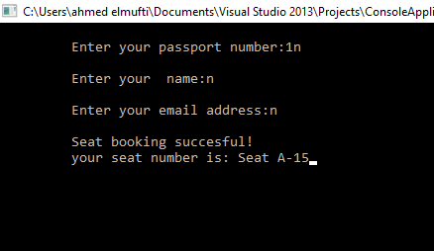

*Figure 7: 15 is the maximum seats number the program could not book any more seat*

After registering 15 users in the system now the flight supposed to be full and cannot except anymore.

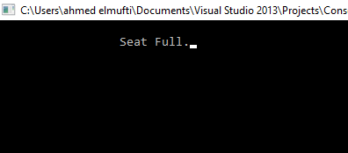

*Figure 8: it is displaying the no more seat available that cannot book any seat*

The system will pop out to notify the user that there’s no seat available, the flight contains only 15 seat after that it is displaying it is full sorry we cannot register anymore.

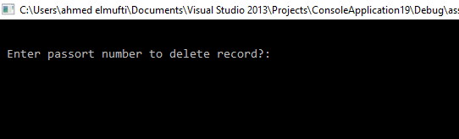

*Figure 9: cancel function*

After the passenger entered 3 and want to cancel the record, after that, the program requires the user to enter which passport number to delete it. For example, that mufti registered the seat in the flight and he wants to cancel it.

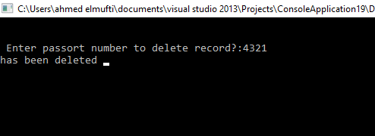

*Figure 10: Delete Rocord*

The system asking mufti to enter his passport number to cancel it from the system without any problems and in efficient way. After mufti entered his passport number the system pop in your record has been deleted from the system.

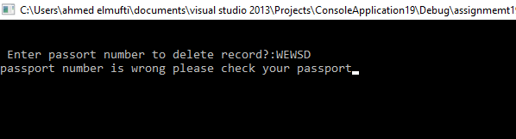

Figure 11: Wrong passport no. given

If mufti entered the wrong passport number by mistake the system pop in hey ahmed passport number is wrong, please check your passport number and enter it again.

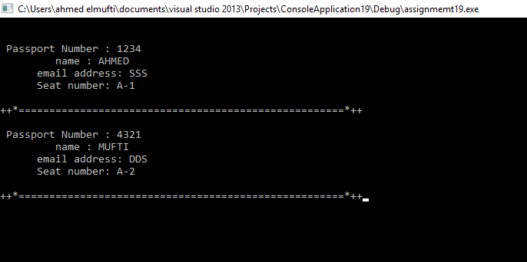

Figure 12: Give a suitable title

The interface is displaying all the users record that now you have two seats ahmed with his details and mufti with his details as well. There’s line between the users to make it clear to read and do not misunderstand it.

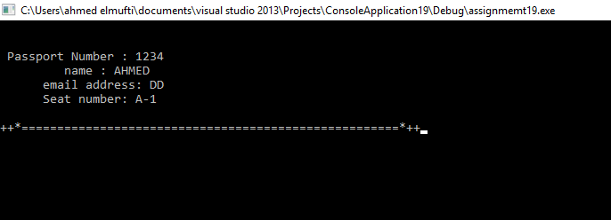

Figure 13: Give a suitable title

After mufti cancel his seat from the system, the interface is showing that only ahmed in the system and mufti’s seat already deleted.

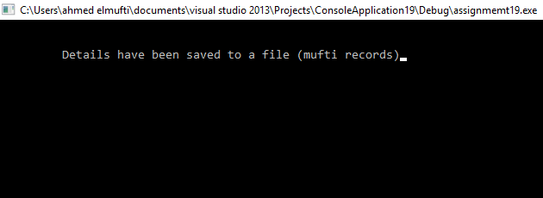

Figure 14: Give a suitable title

After entered 4 which is exit function, it is storing all the records into file with all the passenger’s details in mufti record.

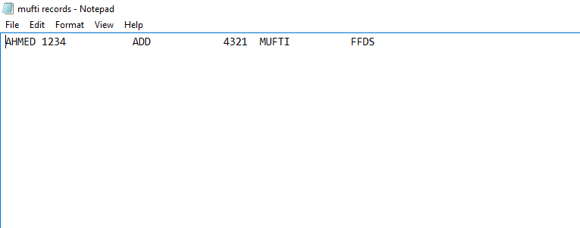

The interface is showing the record in notepad which is the storing part and it is displaying ahmed and his details after mufti cancel his record.

# Chapter 3 Conclusion

**Learning Outcome**

The Airline reservation system is designed for users to reserve a seat, cancel, display seat and exit the system. A formula is included in the function to calculate the seats are reserved. A few flow charts are created for explaining the process of the Airline reservation system.

From this assignment, I have learnt to implement a few C concepts in the future projects such as functions, switch statement and do…while statement, arrays, pointers and structures in the program. I have also learnt to create flow charts for explaining the program using Microsoft Visio 2013.

**Future Scope**

* We can use graph theory to include route map in this project
* We can add database to our project to store all employee and passenger information of the Airlines system.

# References

1. Author Initial. Author Surname, Title. City: Publisher, Year Published, p. Pages Used.
2. A. Rezi and M. Allam, ”Techniques in array processing by means of transforma- tions, ” in Control and Dynamic Systems, Vol. 69, Multidemsional Systems, C. T. Leondes, Ed. San Diego: Academic Press, 1995, pp. 133-180.
3. O. B. R. Strimpel, ”Computer graphics,” in McGraw-Hill Encyclopedia of Science and Technology, 8th ed., Vol. 4. New York: McGraw-Hill, 1997, pp. 279-283.
4. K. Schwalbe, Information Technology Project Management, 3rd ed. Boston: Course Technology, 2004.